Hamatech for Post CMP Cleaning

The Hamatech cleaner is used for cleaning both sides of the wafer after CMP. It will clean and dry the wafer faster and cleaner than can be done by hand. The tool uses dilute ammonium hydroxide and a PVA sponge brush to remove the CMP slurry particles from the wafer. Cleaning must be done immediately after polishing and before the wafer is allowed to dry. Once the wafer has dried, only chemical etching will effectively remove the slurry particles.

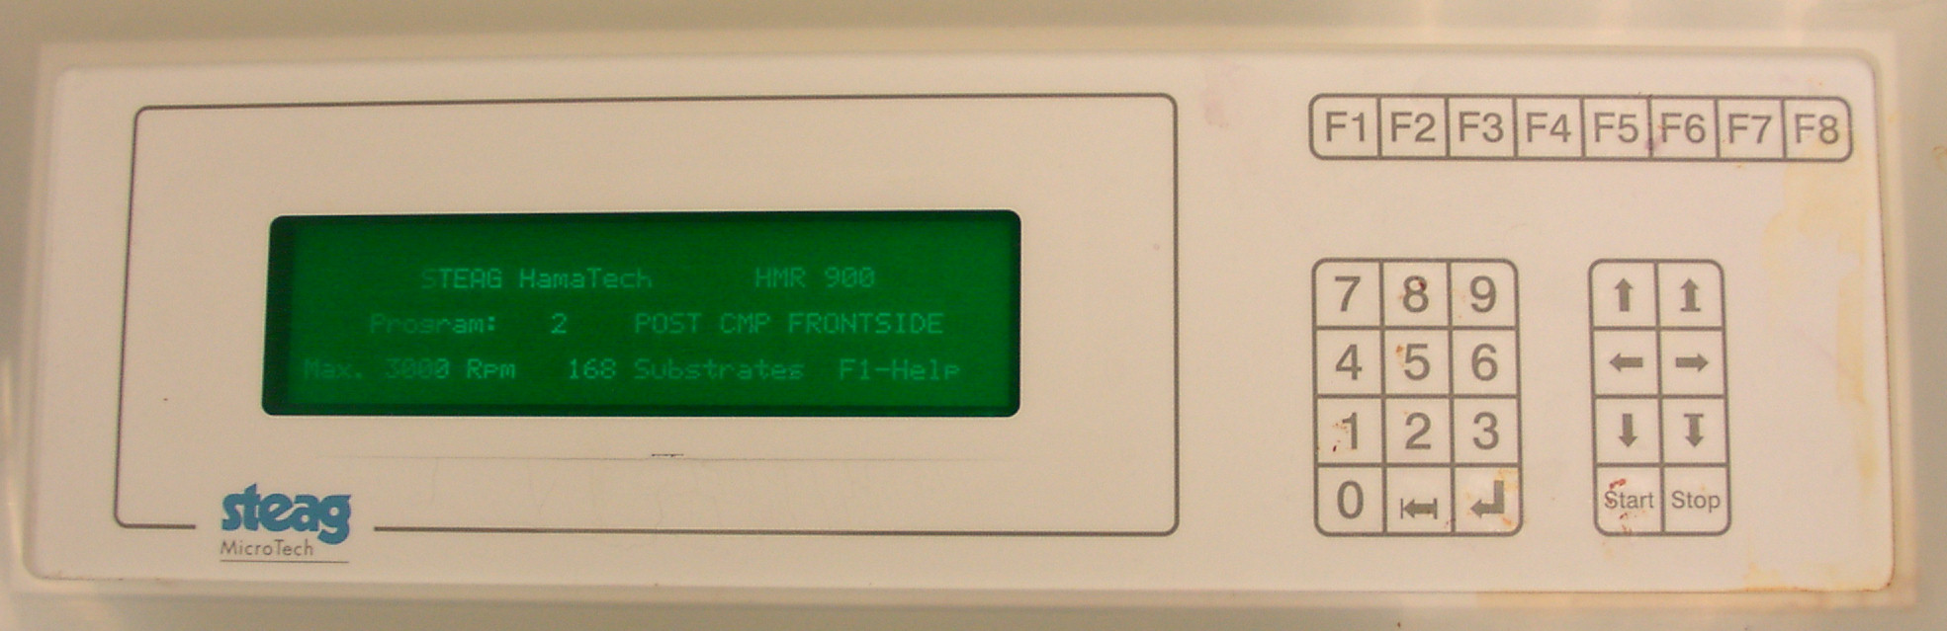
Return Key
Program Select
Door Open / Close
Start Button

Loading / Unloading Wafers:

Press F4 to open the process door.
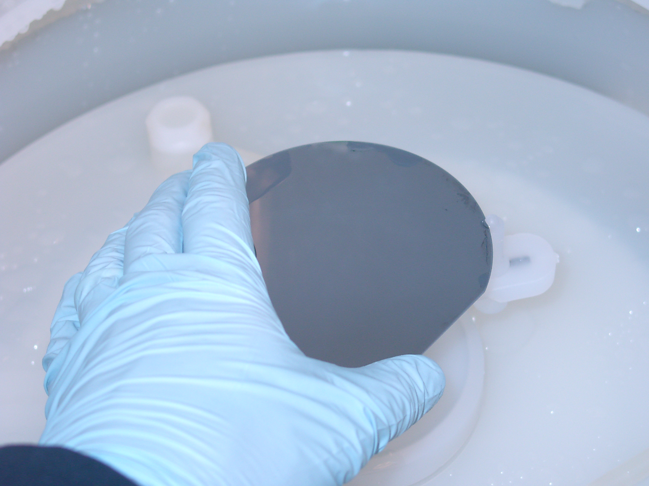

Pin
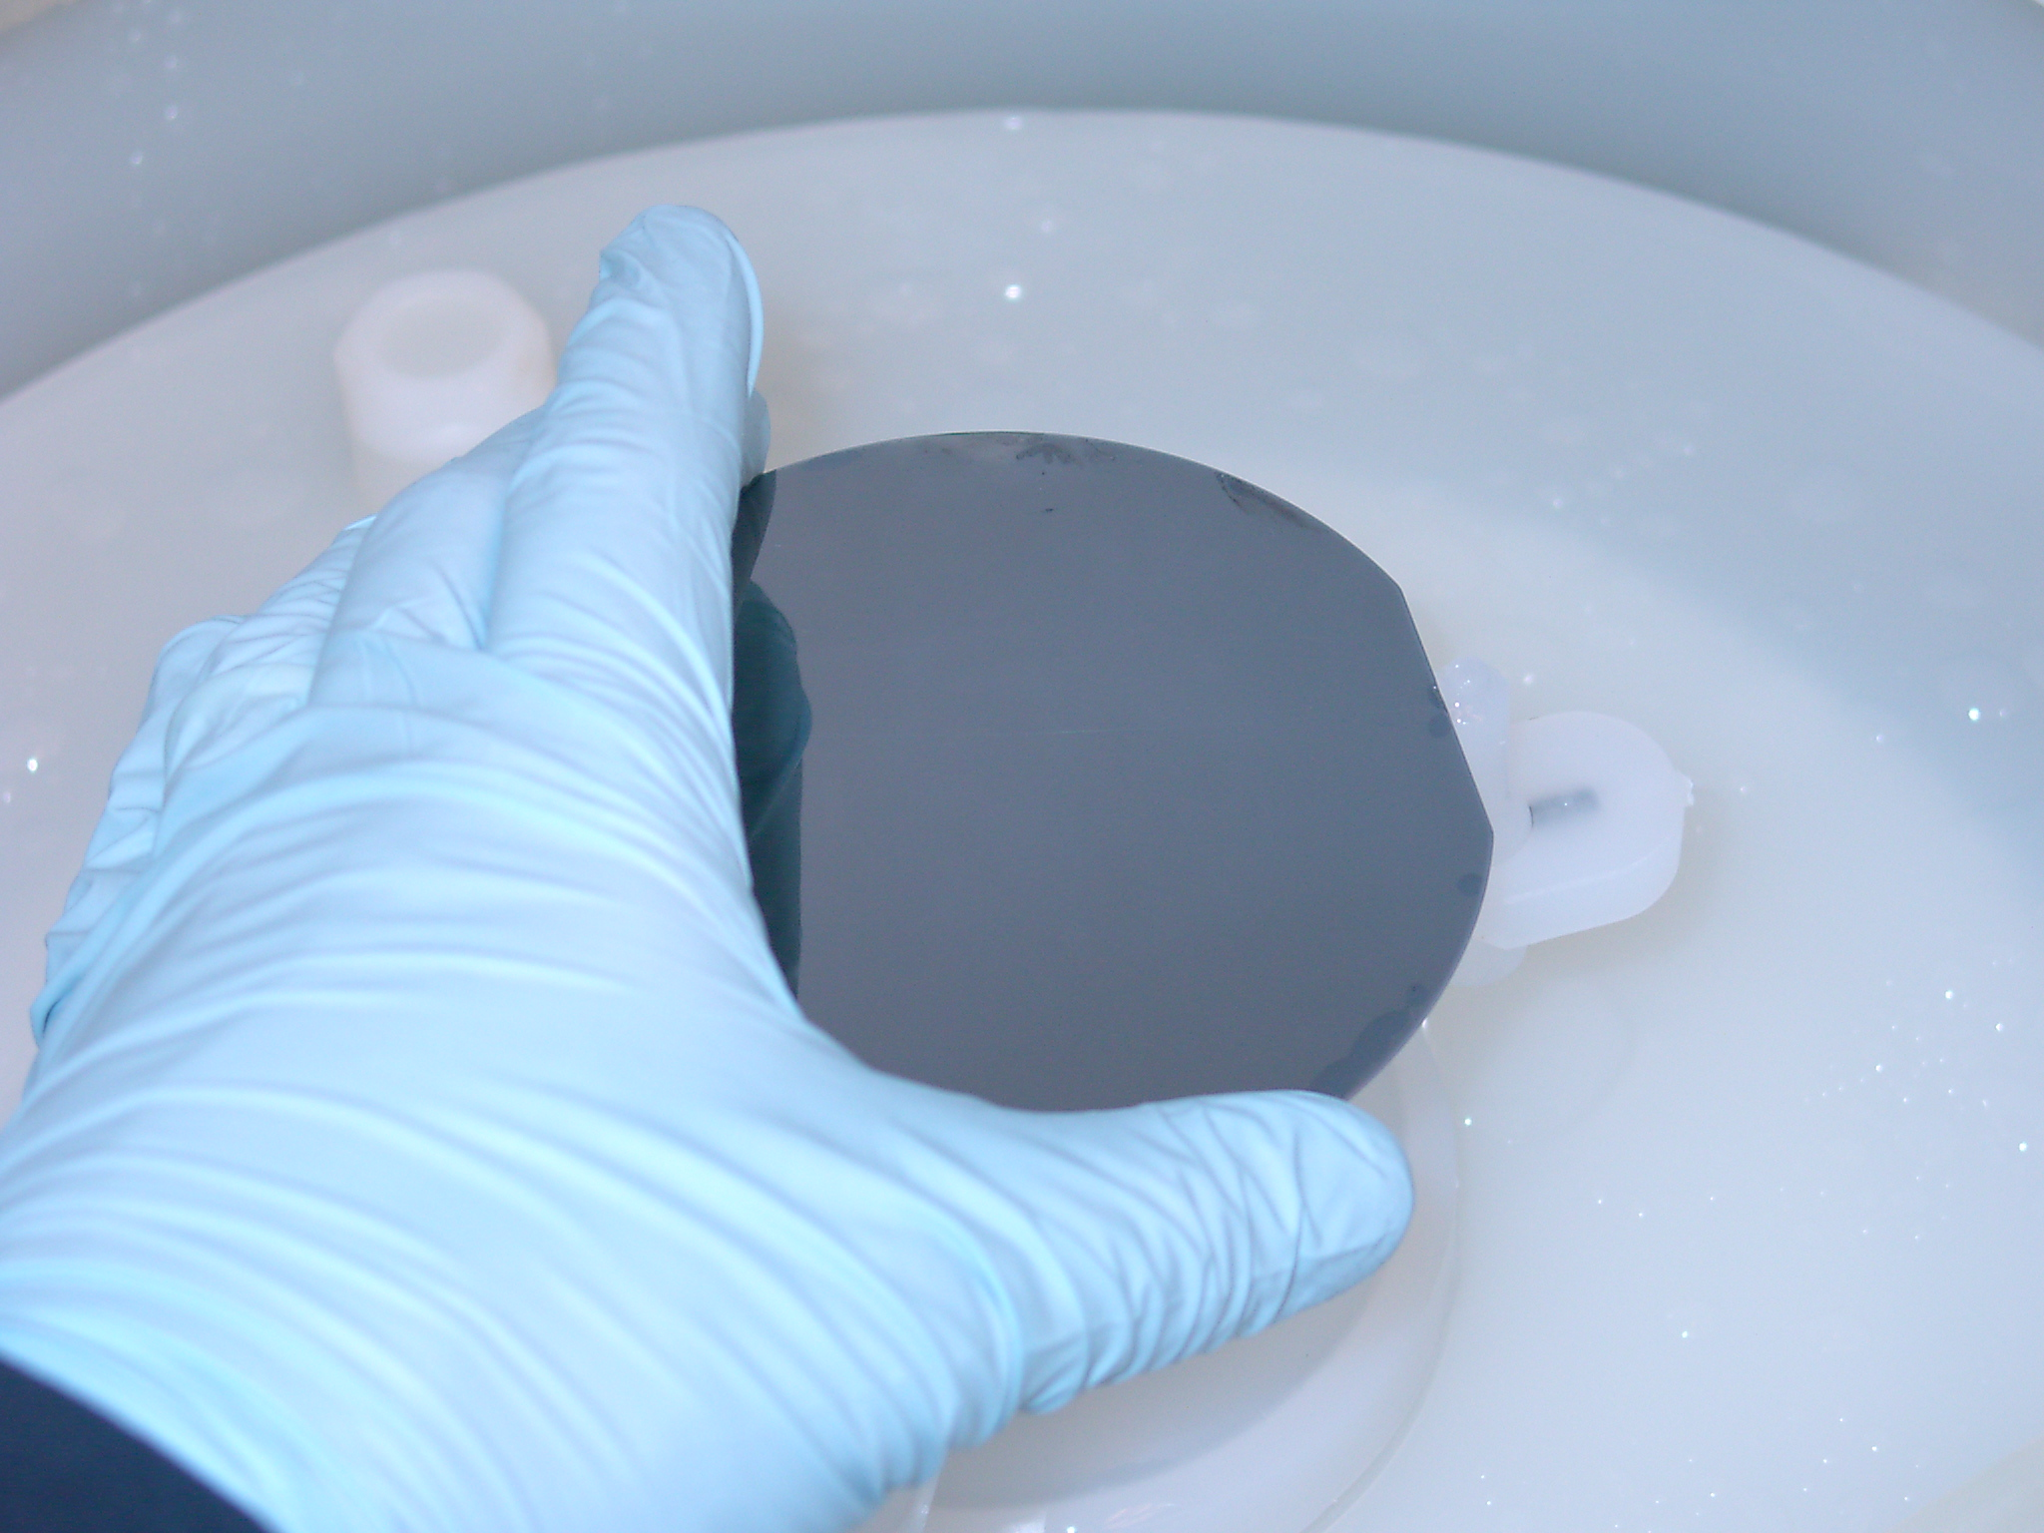
Place the wafer against two of the pins with the flat located at the third pin. Rotate the wafer in the chuck so that it is held in place by all three pins.

Use the up and down arrow keys (<↑> and <↓>) to select the program of interest. Press <start> to begin the program. The tool will beep when the program is done. Press the return key to end the program and open the door.

Post CMP Cleaning

- Load your wafer face down in the chuck.
- Select the “Post CMP Backside” recipe and run it. This recipe will briefly clean and rinse the back of the wafer but will not spin it dry.
- Remove your wet wafer and load it face up in the chuck.
- Select the “Post CMP Frontside” recipe and run it. This will thoroughly clean and dry the front of the wafer.
- When you are finished using the tool, press <F4> to close the process door.

